**SO INVULBLAD NAAM:**

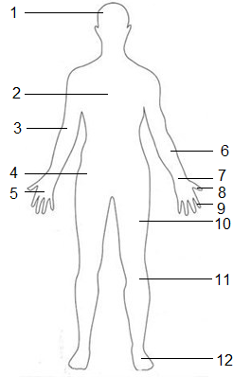

|  |  |
| --- | --- |
|  | **Niveau 1** |
| **1** |  |
| **2** |  |
| **3** |  |
| **4** |  |
| **5** |  |
| **6** |  |
| **7** |  |
| **8** |  |
| **9** |  |
| **10** |  |
| **11** |  |
| **12** |  |

|  |  |
| --- | --- |
| **13** |  |
| **14** |  |
| **15** |  |
| **16** |  |
| **17** |  |
| **18** |  |
| **19** |  |
| **20** |  |
|  |  |
|  | **Niveau 2** |
| **A** |  |
| **B** |  |
| **C** |  |
| **D** |  |

